N4DIG08 8ch Input Output module Manual
Features:
1 Working voltage: DC 12V (6-24V)
2 Working current: 10-16MA
3 MODBUS RTU 03 06 16 command control mode
4 Three functional modes can be selected by jumpers: 8 channel input/8 channel output/4 input 4 output
5 Input mode: support 3.3V/5V TTL level input, there are two input modes: low level input (default) and high level input
6 Output mode: 5V TTL level, low level (default)/high level output
7 In MODBUS command mode, it can support up to 247 devices to be used in parallel
8 Input port status supports query (default) and automatic reporting
9 The default baud rate is 9600BPS, which can be configured to support 1200 2400 4800 19200 baud rate
10 Size: 44*31*15
11 Weight: 9 grams (no Pin), 10 grams (with Pin), 12.5 grams (with Terminals)
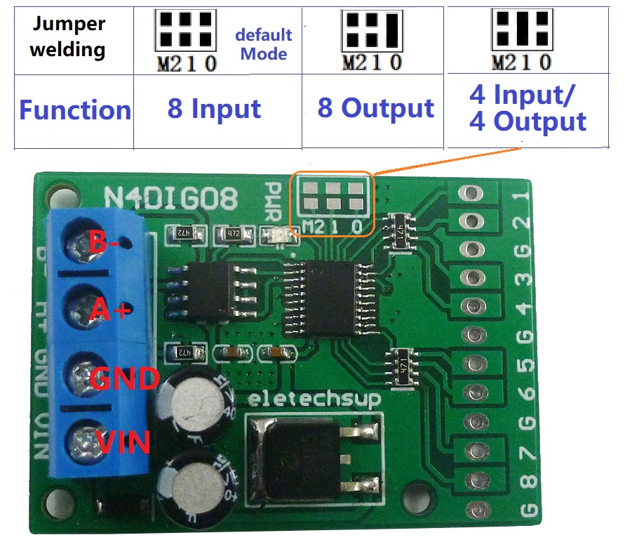
Choose different functions through jumpers on the board:
As 8-channel inputs Please refer to "N4DIG08 MODBUS RTU instruction (8-channel input)"
As 8-channel outputs Please refer to "N4DIG08 MODBUS RTU instruction (8-channel output)"
As 4 input 4output Please refer to "N4DIG08 MODBUS RTU instruction (4 Input 4 Output)"

As an 8-channel input wiring diagram:
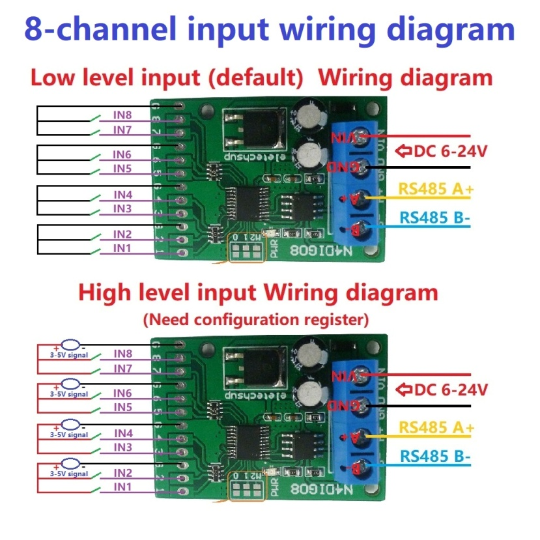
As an 8-channel output wiring diagram:
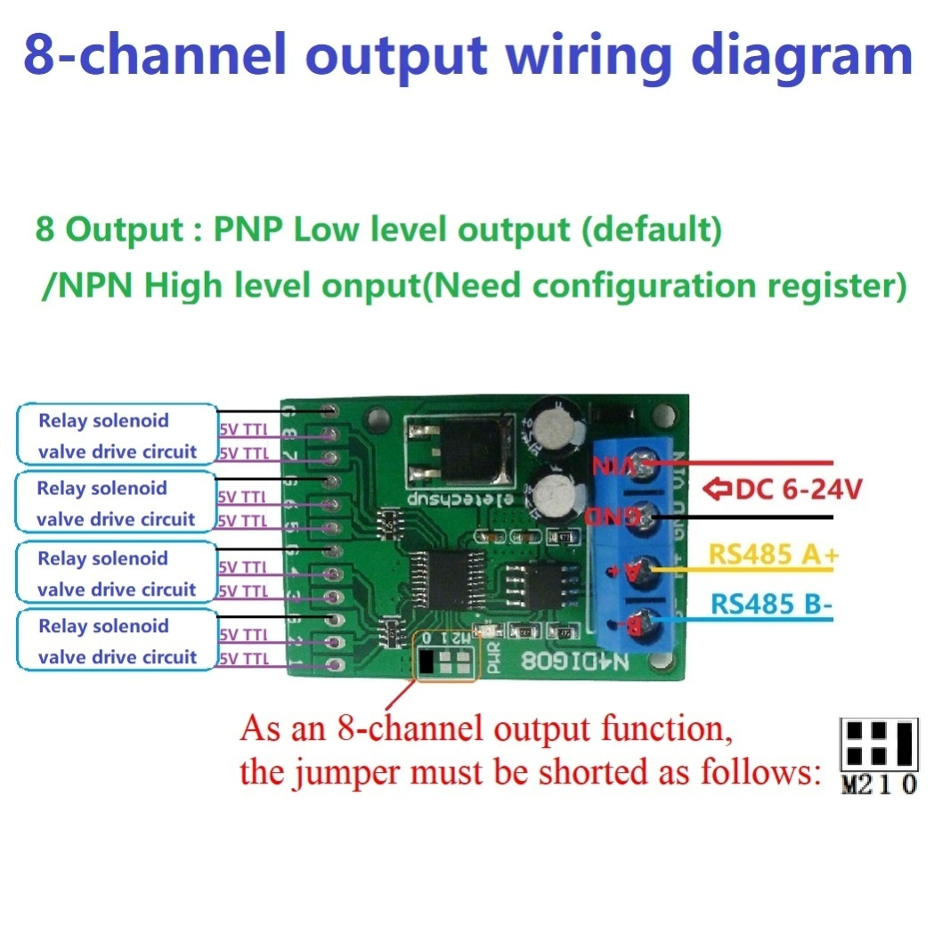
As a 4 input 4 output wiring diagram:
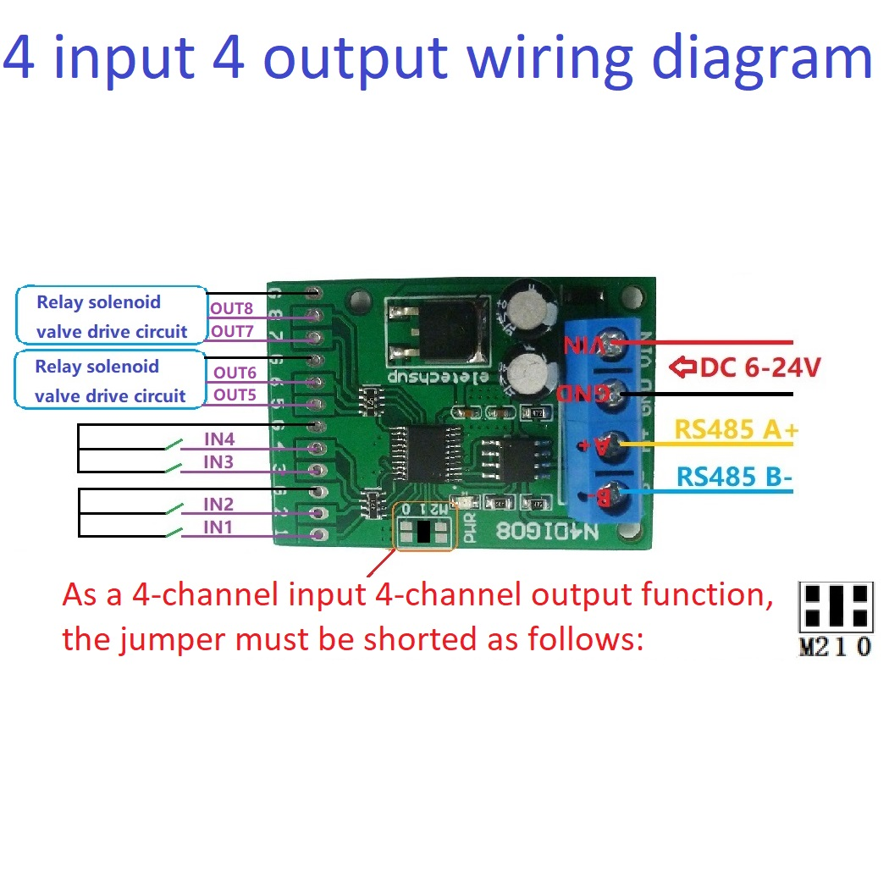

RS485 Wiring diagram:
